Ten Top Tips for Effective Memorisation

- Listen to the work before you start learning it and observe the score carefully. Be aware of how the work makes you feel and spend time focusing particularly on interpretation.
- Take a short passage (perhaps a four bar phrase or a line or two of a piece) and start by memorising the left hand on its own, and then the right hand. Be able to play them through accurately without the music, noting all the unusual features (i.e. large leaps, scale passages etc.). Also pay special attention to fingerings as they can be very useful as a memorisation aid. When you have done this you may find it beneficial to reverse the roles and play the left hand line with the right hand and vice versa. This allows your mind to really know the shape of the musical lines rather than only relying on digital learning which can be dangerous. Practising a line of music with one finger at a time can be advantageous too.
- Then play the passage hands together using the score at first then taking it away as soon as possible. Observe which passages you find difficult to recall. Work thoroughly on those areas (by repeating as well as mentally finding patterns to remember). Most passagework has some unusual feature which will help act as a ‘signpost’. The more ‘signposts’ you can find the better.
- Sing the melodies in your piece and then play them with and without the accompaniment so that you become even more aware of the musical structure. Another valuable exercise at this point may include playing the accompanying material in a piece from memory or playing the accompaniment with the bass line first (if there is one) and then with the melody line. It can be helpful to do all this at slow speeds allowing your mind to digest the musical lines and phrases.
- Work the passage up to tempo with a metronome but without using the score. It’s really important to emphasize how repetition really does assist memory. As mentioned earlier, it’s a good idea to play the piece or the sections within your piece without the score as soon as possible so that your fingers and brain accustom themselves to this swiftly.
- Repeat steps 2 - 5 on other sections of the piece.
- Practice other pieces before coming back to test your memory during practice sessions. You will probably find that you can’t remember every detail at this stage. Memory takes time and persistence so just keep working on it.
- Test your memory on the same passages the next day (and on consecutive days) before resuming working on other sections in the piece.
- Once you have committed your piece to memory, work at it backwards, i.e. playing and analysing the last phrase first. Learning backwards can really work well and professionals sometimes employ this method.
- Enjoy playing the piece through regularly to prompt your memory (perhaps once a day, or whenever you are able to practice).

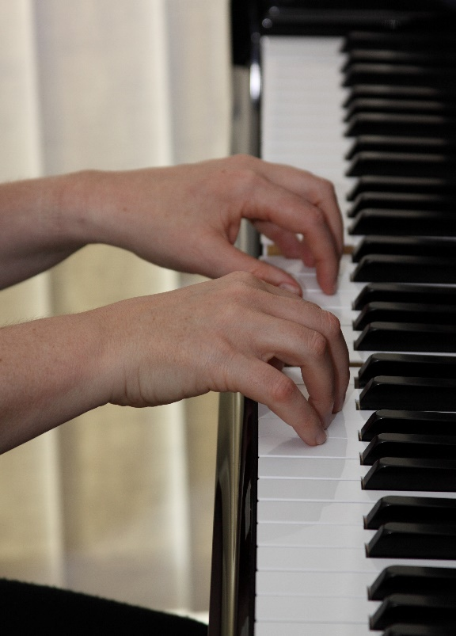
© Melanie Spanswick

